**Game Design Using: C# Windows forms game and scoreboard connected to a MySQL database.**

Game design has been in the circulation for over years and through these, world are changing in most area such as family happiness, economic improvement, academic excellence and in the research area, among few:

“GAME DESIGN”

**Design for - “GAME DESIGN”**

**NAME: ADESIJI SOLOMON OLUTUNDE**

**STUDENT NUMBER: 1101562431**

**MODULE: FOUNDAMENTALS OF COMPUTING**

**MODULE CODE: CET101 Fundamentals of Computing**

**2013-14**

**(PORTFOLIO 5)**

# Conclusion:

Table of Contents

Table of Content 2

Introduction 2

Why selecting this particular game: 2

The functionality of this game 2

Demonstration on how the C# window form was used: 2

Design and Implement an interactive standalone: 2

Demostrate functionality of the two functions: [C# window form and Flash projector] 2

Conclusion: 2

References: 2

# 

# Introduction

Game can be described as a form of competitive activities or sport played according to rules, in its synonyms; it can be categorized as the match, context, tournament, meetings, e.t.c;

It can also be classified as the activity that one engages in for an amusement, for example computer games; and it can be in a synonyms ; like pastime, diversion, amusement, entertainment, distraction, divertissement, recreation, sport, activities and leisure activities.

The Oxford definition of Game; it is a meeting for sporting contest: “the Olympic Games” or a person’s performance in a game; a person’s standard of play;

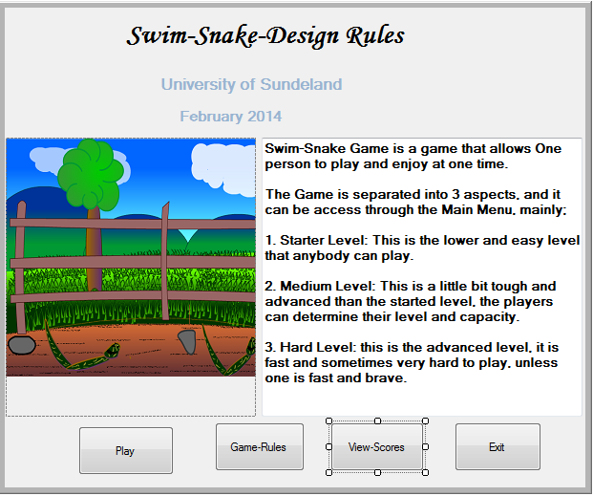

Meanwhile, this particular article/report will address the Snake game using C# programming, the game will comprises of different activities and functions that the player will find interesting. The game is actually split into 3 consecutive aspects; it has different levels, such as:

1. Lower game, (2) medium game and (3) Hard game.
2. 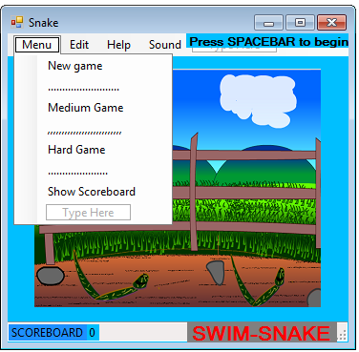

Music section:

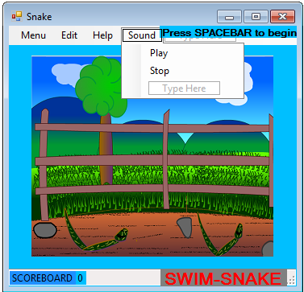

Determining the level of game:

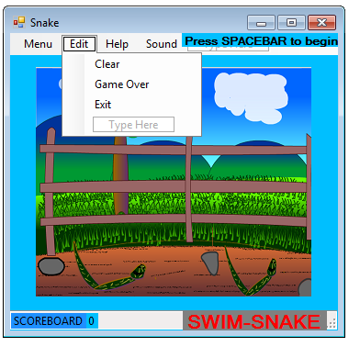

1. 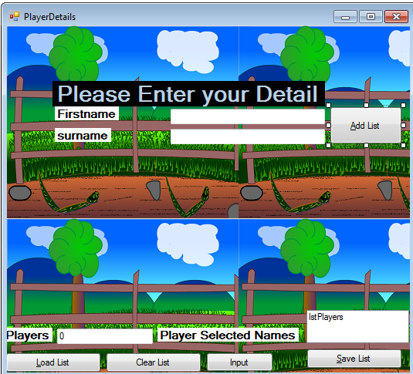

The background to the game

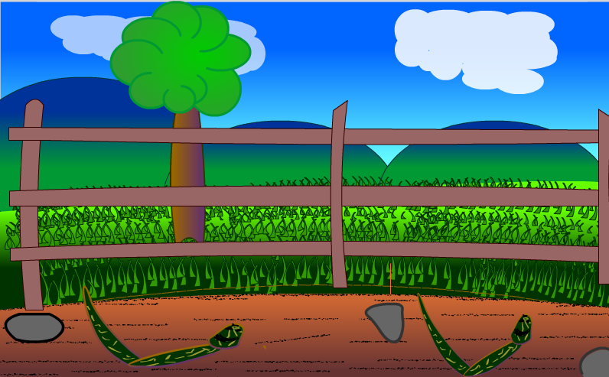

Snakes searching for food:

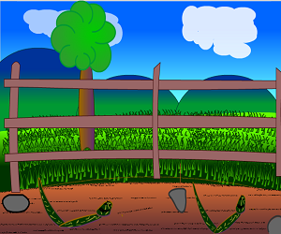

After finishing the game, you can check your scores by clicking the menu page and click scoreboard:





View the score here:

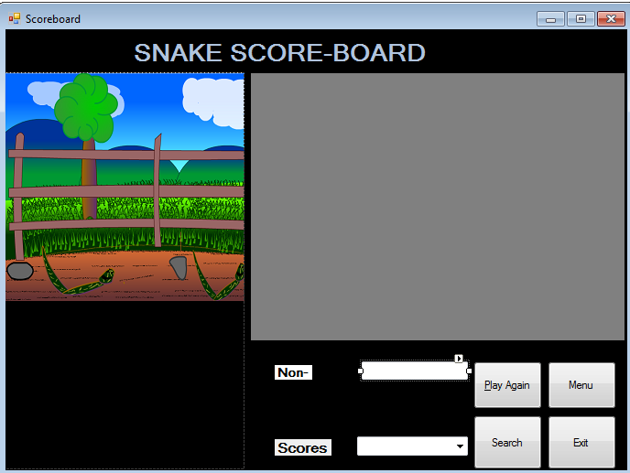

Player must enter names:

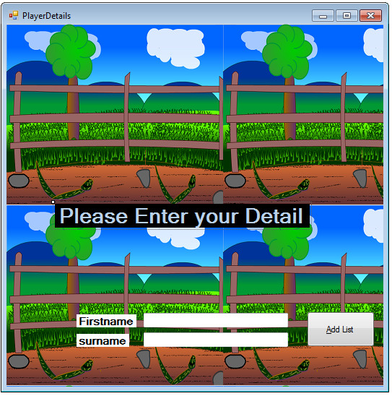

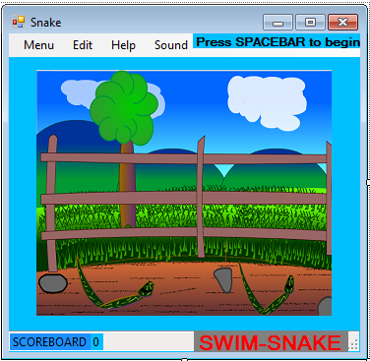

## Snake searching for food

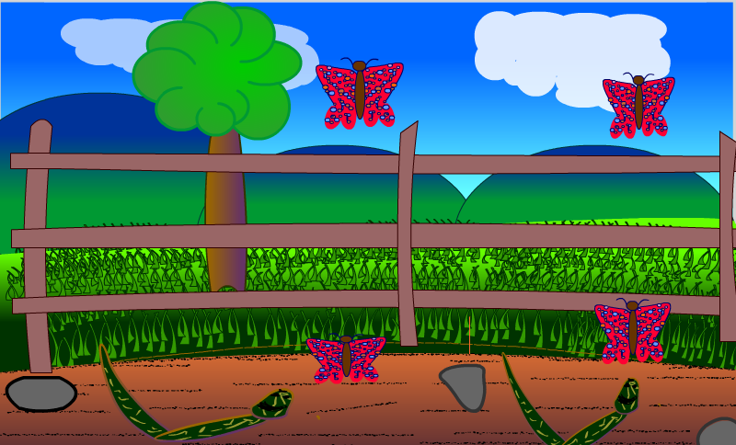

Conclusion:]

Easy to play game and very interesting

# References: